Postman software ----- postman is a software which can give a messege of get,post,put,delete

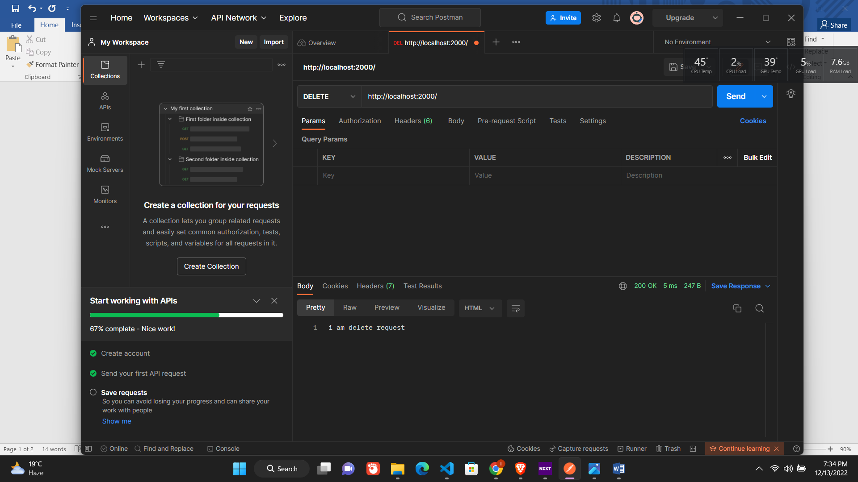

This is postman software

http request:

there are 4 type of request🡪

-get(read)

-post(create)

-put(update)

-delete(delete )